MCA202- Software Engineering Lab

TITLE OF PROJECT
MCA202 Software Engineering Project Report
End-Semester Evaluation
Submitted by:
(2025010048)ISHROOP SINGH BAJAJ
(2025010058)KASHISH BHASIN
(2025010059)KAVYA SHAH
MCA First Year
Team Id: 9
Submitted to:
MS. NISHA THAKUR
Computer Science and Engineering Department
TIET, Patiala
May 2026

TABLE OF CONTENTS of SRS
Chapter No. | Topic | Page No.
1 | Introduction
 | 1.1 Purpose of this Document | 17
 | 1.2 Scope of the Development Project | 17-18
 | 1.3 Definitions, Abbreviations and Acronyms | 19
 | 1.4 References | 20
 | 1.5 Overview | 21
2 | Overall Description
 | 2.1 Product Perspective | 21-22
 | 2.2 Product Functions | 23
 | 2.3 User Characteristics | 24
 | 2.4 General Constraints, Assumptions and Dependencies | 25
 | 2.5 Apportioning of the Requirements | 25
3 | Specific Requirements
 | 3.1 External Interface Requirements | 26
 | 3.2 Detailed Description of Functional Requirements | 27
 | 3.2.1 Functional Requirements for Student Interface | 28
 | 3.2.2 Functional Requirements for Administrator Interface | 28-29
 | 3.3 Performance Requirements | 29
 | 3.4 Logical Database Requirements | 30
 | 3.5 Quality Attributes | 31
 | 3.6 Other Requirements | 32

S.No. | Assignment | Page No.
1. | Planning Phase
1.1 | i. Project Write Up | 4-5
2. | Requirement Analysis Phase
2.1 | i. Use Case Template | 6-13
2.2 | ii. Use-Case diagram | 14
2.3 | iii. Data Flow Diagrams - Level 0, Level 1 | 15-16
2.4 | iv. Software Requirement Specification (SRS) in IEEE Format | 17-32
3. | Design Phase
3.1 | i. Class Diagram | 33
3.2 | ii. Module Structure Chart (Architectural Design) | 34
3.3 | iii. Swimlane Diagrams | 35
3.4 | iv. Sequence Diagrams | 36
4. | Coding and Testing
4.1 | Screenshots of Working GUIs of the Project on the basis of Use Case Scenario | 37-46
4.2 | Cyclomatic complexity calculation for all code snippets | 46-52
4.3 | Test Case Report (by the Testing Team)
4.4 | Screenshots of working GUIs of the project - Labelling of Errors (by the Testing Team)
4.5 | Screenshots of the improved version of the Working Modules (by the Developer’s Team)
4.6 | Test Case Report with improvements (highlighted) (by the Developer’s Team)
TABLE OF CONTENTS

- PLANNING PHASE
  - Project Write Up

1.1.1 Need of the Project
In universities and colleges, classrooms are equipped with smart devices such as microphones, projectors, air conditioners, computers, and internet connections. However, very often these devices stop working properly. When such problems occur, teachers waste valuable lecture time trying to fix them or searching for another classroom. Students also get disturbed, and admins are informed very late, which delays the repair process.
Currently, there is no centralized system where teachers, students and admin can communicate about classroom issues in real time. Most of the time, complaints are made verbally, which leads to confusion, delay, and poor classroom management. This creates a need for a system that can track classroom issues, inform admins in advance, and suggest alternative classrooms so that lectures can continue smoothly.

1.1.2 Solution
The Smart Classroom Logger System is developed to solve this problem by providing a single digital platform for managing classroom infrastructure issues. Through this application, teachers and student can easily report any problem related to classroom equipment.
Admins can update the status of classrooms in the morning or evening, informing whether the equipment is working or under repair.
The system also suggests available classrooms if a particular classroom is not usable, saving lecture time and avoiding confusion. This solution improves coordination between teachers, admins, and students and helps in maintaining a smart and efficient campus environment.

1.1.3 Functional Requirements
- Allow teachers and students to report classroom issues such as mic, projector, AC, computer, or internet problems.
- Allow admins to update the repair status of classroom equipment in advance.
- Display the current status of each classroom (working, under repair, unavailable).
- Suggest alternative classrooms when the assigned classroom is not usable.
- Send notifications to teachers when an issue is resolved or when a classroom is unavailable.

1.1.4 Quality Attributes

- Usability: The system is designed to be simple and user-friendly so that teachers, students, and admins can easily use it without technical training. The interface is clean, with clear buttons for reporting issues, checking status, and viewing classroom suggestions.
- Reliability: The application provides reliable and accurate information about classroom availability and equipment status. All updates are stored in a centralized database so users always get the latest information.
- Scalability: The system can be used for multiple departments, buildings, and campuses without changing the core system.
- Extensibility: New features such as QR-based reporting, Al-based fault prediction, and analytics dashboards can be added in future version.
2. Requirement Analysis Phase
2.1 USE CASE TEMPLATE

1. Use Case Title: Register / Login

2. Abbreviated Title: User Login

3. Use Case ID: UC-01

4. Actors: Student, Teacher, User

5. Description:
User registers a new account or logs into the system.

6. Pre-Conditions:
i) User must have valid credentials

7. Task Sequence (Normal Flow):
i) User selects Register/Login
ii) Enters username and password
iii) System verifies details
iv) Dashboard is displayed

8. Post-Conditions:
User successfully logged in

1. Use Case Title: QR Scan

2. Abbreviated Title: Scan QR

3. Use Case ID: UC-02

4. Actors: Student, Teacher

5. Description:
User scans classroom QR code for attendance or room logging.

6. Pre-Conditions:
i) User must be logged in
ii) QR code must be available

7. Task Sequence (Normal Flow):
i) User selects QR Scan
ii) Camera opens
iii) QR scanned successfully
iv) Data stored in system

8. Post-Conditions:
Attendance or room entry marked

1. Use Case Title: Manual Entry

2. Abbreviated Title: Manual Log

3. Use Case ID: UC-03

4. Actors: Student, Teacher

5. Description:
User manually enters room details if QR scan fails.

6. Pre-Conditions:
i) User must be logged in

7. Task Sequence (Normal Flow):
i) User selects Manual Entry
ii) Enters room number/details
iii) Submits information
iv) System stores data

8. Post-Conditions:
Manual room log saved

1. Use Case Title: Raise Complaint

2. Abbreviated Title: Complaint

3. Use Case ID: UC-04

4. Actors: Student, Teacher, User

5. Description:
User submits complaint related to classroom issues.

6. Pre-Conditions:
i) User must be logged in

7. Task Sequence (Normal Flow):
i) User selects Raise Complaint
ii) Enters complaint details
iii) Clicks submit
iv) Complaint stored in system

8. Post-Conditions:
Complaint registered successfully

1. Use Case Title: View Complaint Status

2. Abbreviated Title: Complaint Status

3. Use Case ID: UC-05

4. Actors: Student, Teacher, User

5. Description:
User checks status of submitted complaint.

6. Pre-Conditions:
i) Complaint must already exist

7. Task Sequence (Normal Flow):
i) User opens complaint section
ii) Selects complaint
iii) System shows status

8. Post-Conditions:
Complaint status displayed

1. Use Case Title: Room Booking

2. Abbreviated Title: Book Room

3. Use Case ID: UC-06

4. Actors: Teacher, User

5. Description:
User requests classroom booking.

6. Pre-Conditions:
i) User must be logged in

7. Task Sequence (Normal Flow):
i) User selects Room Booking
ii) Chooses room and time slot
iii) Submits request
iv) System stores request

8. Post-Conditions:
Room booking request submitted

1. Use Case Title: View Room Booking Status

2. Abbreviated Title: Booking Status

3. Use Case ID: UC-07

4. Actors: Teacher, User

5. Description:
User checks room booking request status.

6. Pre-Conditions:
i) Booking request must exist

7. Task Sequence (Normal Flow):
i) User opens booking status
ii) System displays approval/rejection status

8. Post-Conditions:
Booking status shown

1. Use Case Title: Admin Login

2. Abbreviated Title: Admin Access

3. Use Case ID: UC-08

4. Actors: Admin

5. Description:
Admin logs into admin panel.

6. Pre-Conditions:
i) Admin credentials required

7. Task Sequence (Normal Flow):
i) Admin enters credentials
ii) System verifies login
iii) Admin dashboard displayed

8. Post-Conditions:
Admin logged in successfully

1. Use Case Title: Generate QR Code

2. Abbreviated Title: QR Generate

3. Use Case ID: UC-09

4. Actors: Admin

5. Description:
Admin generates QR code for attendance or login sessions.

6. Pre-Conditions:
i) Admin must be logged in

7. Task Sequence (Normal Flow):
i) Admin selects Generate QR Code
ii) System creates QR code
iii) QR displayed or shared

8. Post-Conditions:
QR code generated successfully

1. Use Case Title: Manage Room Request

2. Abbreviated Title: Manage Booking

3. Use Case ID: UC-10

4. Actors: Admin

5. Description:
Admin approves or rejects room booking requests.

6. Pre-Conditions:
i) Admin logged in
ii) Requests available

7. Task Sequence (Normal Flow):
i) Admin views requests
ii) Selects request
iii) Approves or rejects
iv) Status updated

8. Post-Conditions:
Booking request managed successfully

1. Use Case Title: View Complaint

2. Abbreviated Title: View Issues

3. Use Case ID: UC-11

4. Actors: Admin

5. Description:
Admin views complaints raised by users.

6. Pre-Conditions:
i) Admin must be logged in

7. Task Sequence (Normal Flow):
i) Admin opens complaint panel
ii) Complaint list displayed
iii) Selects complaint to view

8. Post-Conditions:
Complaints viewed successfully

1. Use Case Title: Update Status

2. Abbreviated Title: Status Update

3. Use Case ID: UC-12

4. Actors: Admin

5. Description:
Admin updates complaint or booking request status.

6. Pre-Conditions:
i) Admin must be logged in

7. Task Sequence (Normal Flow):
i) Admin selects request/complaint
ii) Changes status
iii) Saves update

8. Post-Conditions:
Status updated successfully

2.2 USE CASE DIAGRAM

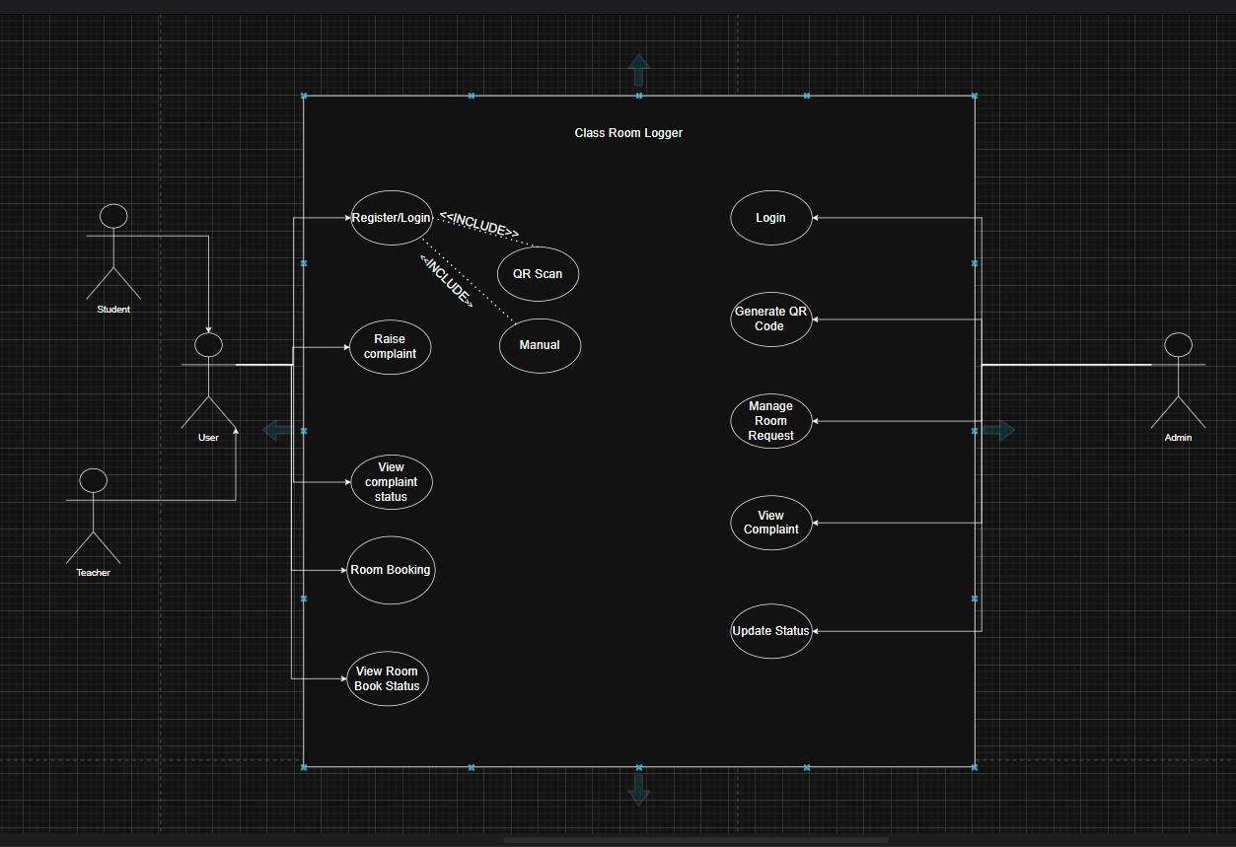

2.3 DATA FLOW DIAGRAM – LEVEL 0 AND LEVEL 1

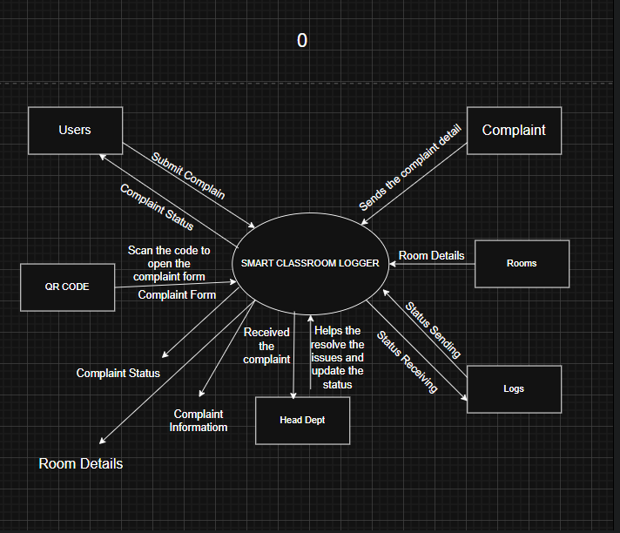

LEVEL 1
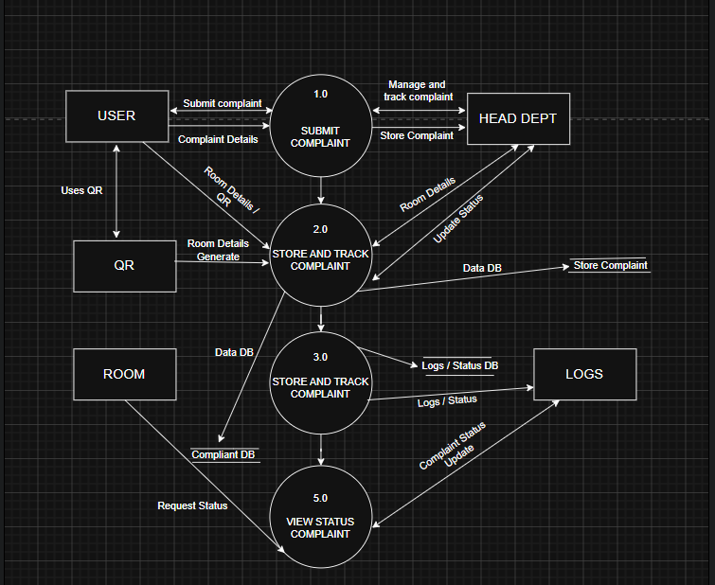

2.4 SOFTWARE REQUIREMENT SPECIFICATIONS (SRS) IN IEEE FORMAT
1. Introduction

1.1 Purpose of this Document

The purpose of this Software Requirements Specification (SRS) document is to provide a detailed and clear description of the Smart Classroom Logger system. This document defines the overall functionality, behavior, and limitations of the system in a structured manner.
This SRS document explains what the Smart Classroom Logger system is expected to do and how different users such as students, admin, and teachers will interact with the system. It describes both functional requirements (what the system should do) and non-functional requirements (how well the system should perform).
The document serves as a common reference for all stakeholders involved in the project, including developers, project guides, testers, and evaluators. It helps in understanding the system requirements clearly before the actual design and development process begins.
The SRS also clearly mentions the features that are included in the Smart Classroom Logger system as well as the features that are not included. This avoids confusion during implementation and ensures that the system is developed according to predefined requirements.
Overall, this document acts as a foundation for designing, implementing, testing, and maintaining the Smart Classroom Logger application.

1.2 Scope of the Development Project

The scope of the Smart Classroom Logger project is to develop a system that manages classroom information in a simple and digital way. The system focuses on maintaining default classroom details such as subject, faculty name, classroom number, and time slot.
It allows authorized users like the student, admin, and teacher to update classroom information, while students can only view the details. The system also supports automatic movement to the next class after the current class is completed.
The project scope is limited to classroom logging and management only. Advanced features like attendance analysis and external system integration are not included in the current version.

The software must be able to perform the following operations:
- Load classroom default information:
The software must be able to load the default details of a classroom such as classroom number, subject name, faculty name, and time slot as soon as the classroom session starts. This ensures that the classroom always begins with predefined and correct information.
- Allow authorized users to update classroom details:
The software must allow authorized users such as the student , admin, and teacher to update classroom information. These updates may include changes in subject, faculty, or class status.
- Log classroom activities:
The software must be able to record all classroom activities and updates in a centralized database. Each update should be stored with details such as user role, time of update, and classroom identifier for future reference.
- Automatically move to the next class:
The software must be able to automatically switch to the next scheduled class once the current class session is completed. This reduces manual effort and ensures smooth classroom transitions.
- Ensure data consistency and reliability:
The software must ensure that all classroom data is stored correctly and remains consistent across the system. Any update made by an authorized user should be immediately reflected in the database.

1.3 Definitions, abbreviations and acronyms

S.No. | Term | Definition
1 | Smart Classroom | A classroom environment that uses digital technology and software systems to manage classroom activities efficiently.
2 | Smart Classroom Logger | A software application designed to record, monitor, and manage classroom information such as subject, faculty, and time slot.
3 | Classroom Default | Predefined classroom details that are automatically loaded when a class session starts, including classroom number, subject, faculty name, and time slot.
4 | Authorized User | A user who has permission to modify classroom data, such as student, admin, or teacher.
5 | Student | A user who can only view classroom information and does not have permission to modify data.
6 | Database | A centralized storage system used to store classroom details, logs, and user information.
7 | Log | A digital record of classroom activities and updates stored in the system for future reference.
8 | Time Slot | The fixed duration assigned to a particular class session.
9 | Class Status | The current state of a class session, such as ongoing or completed.

1.3.2 Abbreviations and Acronyms
Table 2 gives the full forms of commonly used abbreviations and acronyms used in this SRS document

S.No. | Acronym | Full Form
1 | SRS | Software Requirements Specification
2 | CR | student
3 | UI | User Interface
4 | DB | Database
5 | OS | Operating System
6 | CPU | Central Processing Unit
7 | App | Application

1.4 REFRENCES

1. Smart Classroom Automation System (PDF) — proposes an IoT-based automation system using Raspberry Pi, Node-RED & cloud services.
🔗 https://www.internationaljournalssrg.org/IJEEE/2024/Volume11-Issue11/IJEEE-V11I11P114.pdf

2. Impact of Smart Classroom: A Study — research on the effects of smart classrooms in education (survey & analysis).
🔗 https://www.researchgate.net/publication/365614194_Impact_of_Smart_Classroom_A_Study

1.5 Overview

This Software Requirements Specification (SRS) document presents a complete description of the Smart Classroom Logger system in a clear and structured manner. The document is divided into multiple chapters to help readers easily understand the system requirements.
Chapter 1 provides an introduction to the project, including the purpose of the document, scope of the project, important definitions, abbreviations, and references.
Chapter 2 explains the overall description of the system such as product perspective, product functions, user characteristics, and system constraints.
Chapter 3 describes the specific requirements of the system, including detailed functional requirements, performance requirements, database requirements, and quality attributes.
This overview helps readers understand how the document is organized and what information is covered in each section.

2. Overall Description
2.1 Product Perspective
The Smart Classroom Logger is a QR code–based classroom management system designed for smart classrooms. Each classroom is assigned a unique QR code, which is scanned to identify the classroom and load its default details such as subject, faculty, and time slot.
Authorized users like the student , admin, and teacher can update classroom information after scanning the QR code, while students can only view the details. All classroom data and logs are stored in a centralized database. The system also supports automatic transition to the next class after the current session is completed.

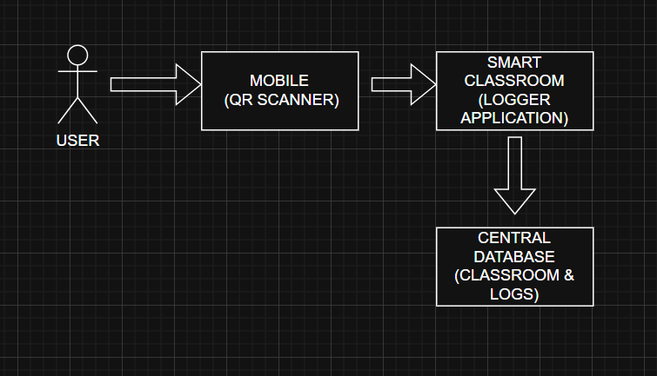

Block Diagram Explanation – Smart Classroom Logger (QR Code Based System)
The block diagram illustrates the overall working flow of the Smart Classroom Logger system using QR code technology. It shows how data moves from the user to the central database through different system components.
1. User
The user is the person who interacts with the system. The user can be a student, student (CR), admin, or teacher. The user initiates the process by scanning the QR code placed inside the classroom.
2. Mobile (QR Scanner)
The mobile device acts as a QR scanner. It scans the unique QR code assigned to a classroom. The QR code contains the classroom identification information. After scanning, the mobile device sends this information to the Smart Classroom Logger application.
3. Smart Classroom ( Logger Application)
The Smart Classroom Logger application is the core component of the system. It processes the scanned QR code data and identifies the classroom. The application loads the default classroom details such as classroom number, subject name, faculty name, and time slot.
Based on the user’s role, the application provides access:
- Students are allowed only to view classroom information.
- Authorized users such as CR, admin, and teacher can update classroom details.
The application communicates with the central database to store and retrieve classroom information.
4. Central Database (Classroom & Logs)
The central database stores all classroom-related data and logs. It maintains classroom details, user updates, and activity logs such as who updated the data and at what time. This ensures data consistency, security, and availability for future reference.

2.2 Product Functions
The Smart Classroom Logger system provides the following main functions to support digital classroom management using QR code technology:
- Classroom Identification using QR Code
The system allows users to identify a classroom by scanning a unique QR code placed inside the classroom. This helps the system to automatically recognize the classroom without manual input.
- Load Default Classroom Information
After scanning the QR code, the system loads the default classroom details such as classroom number, subject name, faculty name, and time slot. This ensures that correct information is available at the start of each class session.
- Role-Based Access Control
The system provides different access levels based on user roles. Students are allowed only to view classroom information, while authorized users such as students , admins, and teachers can update classroom details.
- Update Classroom Details
Authorized users can modify classroom information such as subject, faculty, or class status when required. All updates are validated by the system before being stored.
- Log Classroom Activities
The system records all classroom activities and updates in the form of logs. Each log includes details such as classroom ID, user role, date, and time of the update.
- Store and Retrieve Data from Central Database
The system communicates with a centralized database to store and retrieve classroom information and logs. This ensures data consistency and long-term record maintenance.
- Automatic Transition to Next Class
Once a class session is completed, the system supports automatic transition to the next scheduled class, reducing manual effort and improving classroom flow.

2.3 User Characteristics
The Smart Classroom Logger system is designed to be used by different types of users with varying roles and access permissions. Each user type has different responsibilities and interaction levels with the system.
- Students
Students are the primary users of the system. They are allowed to scan the classroom QR code and view classroom information such as subject name, faculty name, and time slot. Students do not have permission to update or modify any classroom data. It is assumed that students have basic knowledge of using a smartphone and QR code scanning.
- Teacher
Teachers use the system to verify classroom information and update lecture-related details when required. They have permission to modify classroom data and manage class sessions. Teachers are assumed to be comfortable using mobile applications.
- Admin
Admins are responsible for handling technical or system-related updates. They may update classroom status or ensure that the system is functioning properly. admins are expected to have technical knowledge of the system and basic troubleshooting skills.

2.4 General Constraints, Assumptions and Dependencies
This section describes the constraints, assumptions, and dependencies that affect the design and implementation of the Smart Classroom Logger system.
Constraints
- The system requires a mobile device with a working camera to scan QR codes.
- An active internet connection is required for accessing and updating data in the central database.
- The system is limited to smartphone-based access and does not support standalone desktop usage in the current version.
- The QR code must be clearly visible and properly placed inside the classroom for accurate scanning.
- The system interface is designed to be simple with limited graphics to ensure smooth performance on all devices.
Assumptions
- Users have basic knowledge of using smartphones and QR code scanning applications.
- Each classroom has a unique and valid QR code assigned to it.
- Authorized users such as students, teachers, and admins will update classroom data responsibly.
- The central database is always available and properly maintained.
- Class schedules and default classroom details are correctly configured in the system.
Dependencies
- The system depends on the availability of the mobile device camera for QR code scanning.
- The system depends on the central database for storing and retrieving classroom data and logs.
- Proper functioning of the system depends on stable network connectivity.
- The system depends on backend services for data processing and authentication.

2.5 Apportioning of Requirements
The Smart Classroom Logger system is planned to be implemented in the following phases. Each phase will include the same basic functionality, but the scale and features of implementation will increase gradually.
Phase 1: Pilot Phase
In this phase, the Smart Classroom Logger system will be implemented on a limited scale. A few classrooms will be selected, and each classroom will be assigned a unique QR code. Basic functionalities such as QR code scanning, loading default classroom details, role-based access (student, CR, teacher, admin), and storing data in a central database will be implemented. This phase is intended to test the system and identify possible improvements.
Phase 2: Institute-wide Deployment
After the successful completion of the pilot phase, the Smart Classroom Logger system will be deployed across multiple classrooms within the institute. All classrooms will be provided with QR codes, and the system will be used regularly for classroom logging and management. Data storage and logging will be fully operational at this stage.
Phase 3: Extension of the System
In the future, the Smart Classroom Logger system can be extended to support additional features such as attendance management, report generation, analytics, and integration with other institutional systems. These features are not part of the current implementation but may be added in later versions of the system.

3.1 External Interface Requirements
The system provides a simple mobile interface for users.
- The system supports QR code scanning to identify classrooms.
- Classroom details are displayed after QR code scanning.
- Only authorized users can update classroom information.
- Students are allowed only to view classroom details.
- The system runs on smartphones with a camera.
- No extra hardware is required.
- The system connects to a central database.
- Internet connection is required for data access.
- Data communication is secure.

3.2 Detailed Description of Functional Requirements
Table 3 shows the template that will be used to describe the functional requirements for different types of users of the Smart Classroom Logger system. The functional requirements are defined mainly for three types of users: student, authorized user (Teacher/admin), and student cum authorized user. Functional requirements for other user types can be easily derived using this template.
TABLE:
Field | Description
Purpose | A description of the functional requirement and the reason for its existence.
Inputs | Describes the inputs required by the system, the form in which they arrive, the source of inputs, and the valid range of each input.
Processing | Describes how the system processes the input, including validations, timing constraints, and handling of unexpected or abnormal situations.
Outputs | Describes the output produced by the system, including output format, destination, timing, and handling of error messages if any.

3.2.1 Functional Requirements for Student Welcome Screen
Table 4 gives the functional requirements for the Student Welcome Screen of the Smart Classroom Logger system.
Field | Description
Purpose | This screen provides classroom-related information to students after successful scanning of the classroom QR code. The student is allowed only to view the information and no modification is permitted.
Inputs | Input is provided by scanning the classroom QR code using a mobile device. The QR code contains valid classroom identification details.
Processing | The system validates the scanned QR code and retrieves the corresponding classroom details from the central database. If the QR code is invalid, an error message is displayed.
Outputs | The output consists of a welcome screen displaying classroom information such as classroom number, subject name, faculty name, and time slot. In case of an error, an appropriate error message is displayed on the screen.

3.2.2 Functional Requirements for Staff Welcome Screen
Table 5 gives the functional requirements for the Staff Welcome Screen of the Smart Classroom Logger system.
Field | Description
Purpose | This screen provides classroom information and update options to staff members after successful scanning of the classroom QR code. Staff members are allowed to view and update classroom details as required.
Inputs | Input is provided by scanning the classroom QR code using a mobile device. Additional inputs may include updated subject details, faculty name, class status, or time slot entered by the staff member.
Processing | The system validates the scanned QR code and verifies the staff user role. After validation, the system retrieves existing classroom data from the database and allows the staff member to modify the information. All updates are checked for correctness before being saved.
Outputs | The output consists of a welcome screen displaying classroom details along with options to update information. After successful update, a confirmation message is displayed. In case of invalid input or error, an appropriate error message is shown.

3.2.3 Functional Requirements for Student cum Staff Welcome Screen
Table 6 gives the functional requirements for the Student cum Staff Welcome Screen of the Smart Classroom Logger system.

Field | Description
Purpose | This screen provides combined functionality for users who have both student and staff roles. It allows such users to view classroom information as a student and update classroom details as a staff member after scanning the classroom QR code.
Inputs | Input is provided by scanning the classroom QR code using a mobile device. Additional inputs may include classroom updates such as subject name, faculty details, class status, or time slot entered by the user when acting in staff role.
Processing | The system validates the scanned QR code and identifies the user as both student and staff. Based on the selected role, the system either displays classroom information or allows the user to update classroom details. All updates are verified before being stored in the database.
Outputs | The output consists of a welcome screen displaying classroom information with options to switch between student view and staff update mode. Confirmation messages are shown after successful updates, and error messages are displayed in case of invalid inputs.

3.3 Performance Requirements
The performance requirements define the expected performance characteristics of the Smart Classroom Logger system under normal operating conditions.
- The system is designed to run on mobile devices and cannot operate as a standalone desktop application.
- The system shall support multiple users if different classrooms are using the system simultaneously.
- The system shall handle only textual classroom information and QR code data.
- Under normal conditions, the system shall process QR code scanning and data retrieval within a few seconds.
- At least 95% of user operations such as QR code scanning, data loading, and updates shall be completed within 5 seconds.
- The system shall maintain acceptable performance even with an increase in the number of classrooms and users.

3.4 Logical Database Requirements
shows the E-R diagram for the entire system.

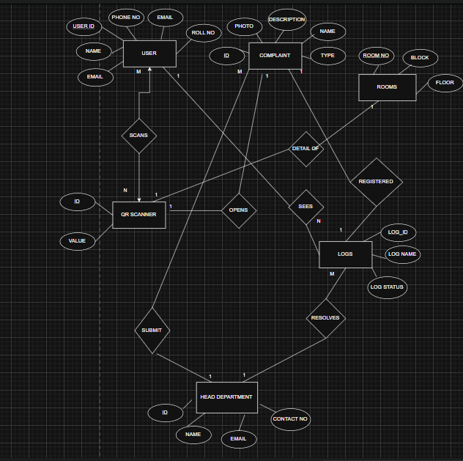

3.5 Quality Attributes
The Smart Classroom Logger system is designed to meet important quality attributes to ensure reliable and efficient operation for all users.
- Usability:
The system provides a simple and user-friendly interface so that students, teachers, and admins can use it easily without special training.
- Reliability:
The system shall reliably store and retrieve classroom information and logs without data loss during normal operation.
- Performance:
The system shall respond quickly to QR code scanning and data requests, ensuring minimal delay during classroom usage.
- Security:
The system shall ensure that only authorized users are allowed to update classroom information. Student access shall be limited to viewing data only.
- Maintainability:
The system shall be easy to maintain and update. Changes in classroom data or system configuration should be manageable without affecting system stability.
- Scalability:
The system shall support an increase in the number of classrooms and users without significant performance degradation.

3.6 Other Requirements
(None at this time)

3. DESIGN PHASE

3.1 CLASS DIAGRAM

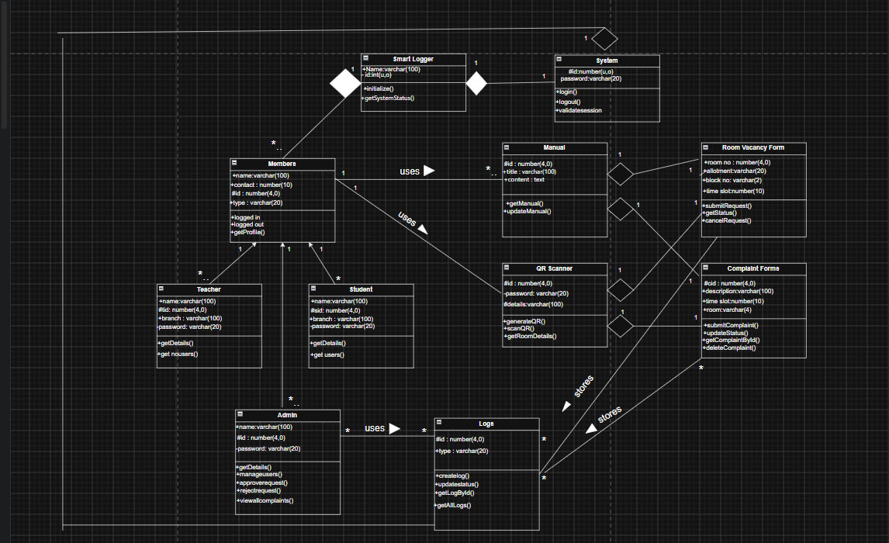

3.2 MODULE STRUCTURE CHART (ARCHITECTURAL DESIGN)

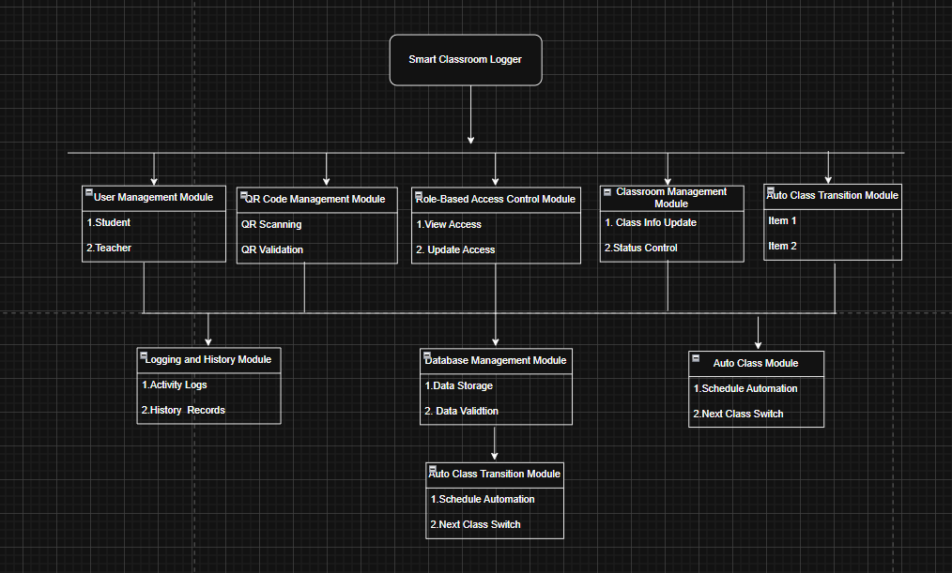

3.3 SWIMLANE DIAGRAM

SWIMLANE : [COMPLAINT]
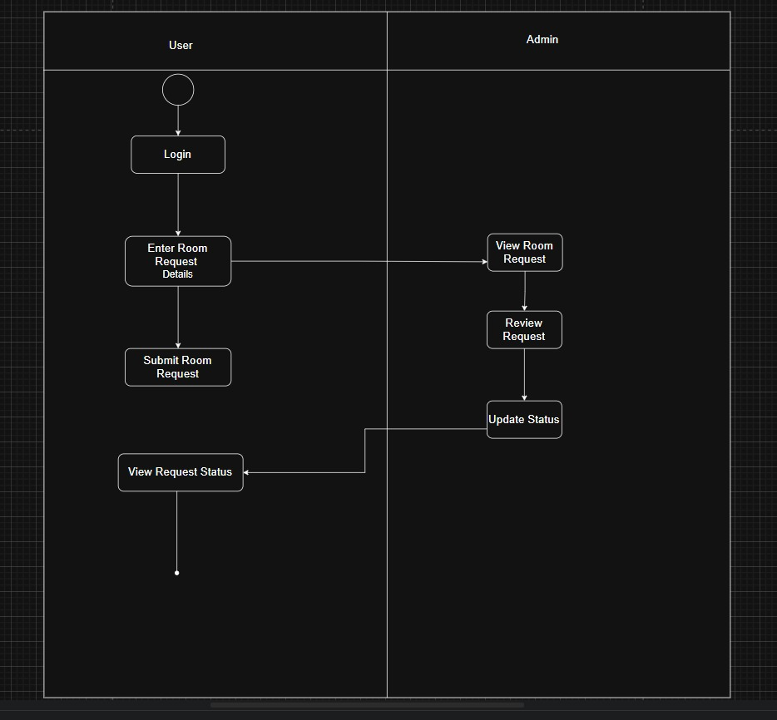

SWIMLANE : [ROOM REQUEST]

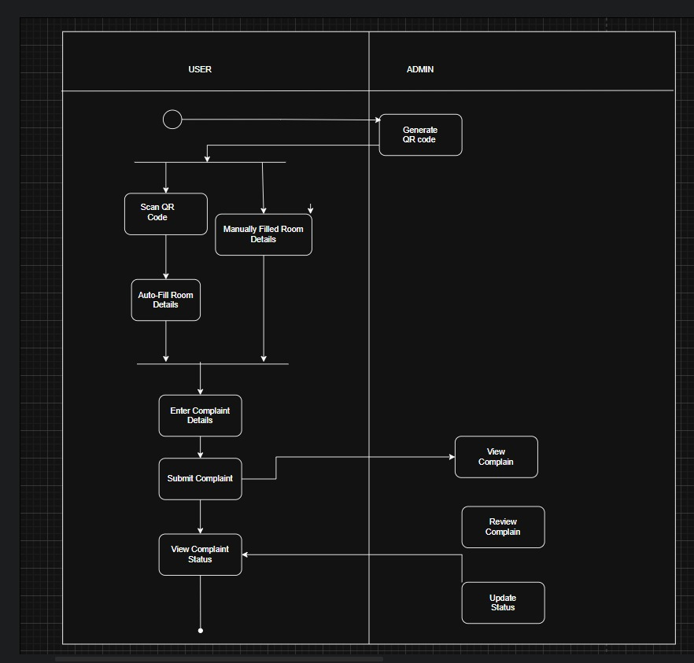

3.4 SEQUENCE DIAGRAM

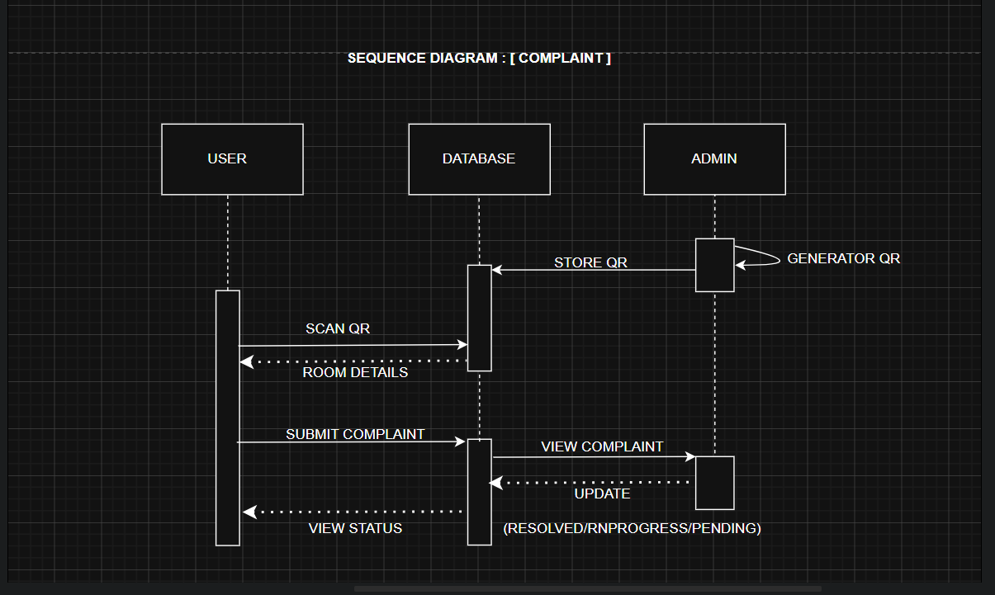

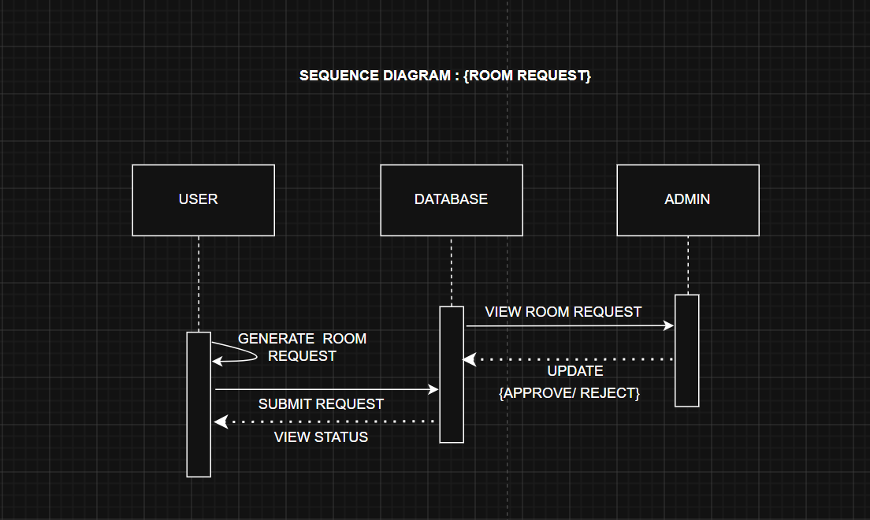

4. Coding and Testing
4.1 Screenshots of Working GUIs of the Project on the basis of Use Case
Scenario
4.1.1 Admin Dashboard : View All Complaints
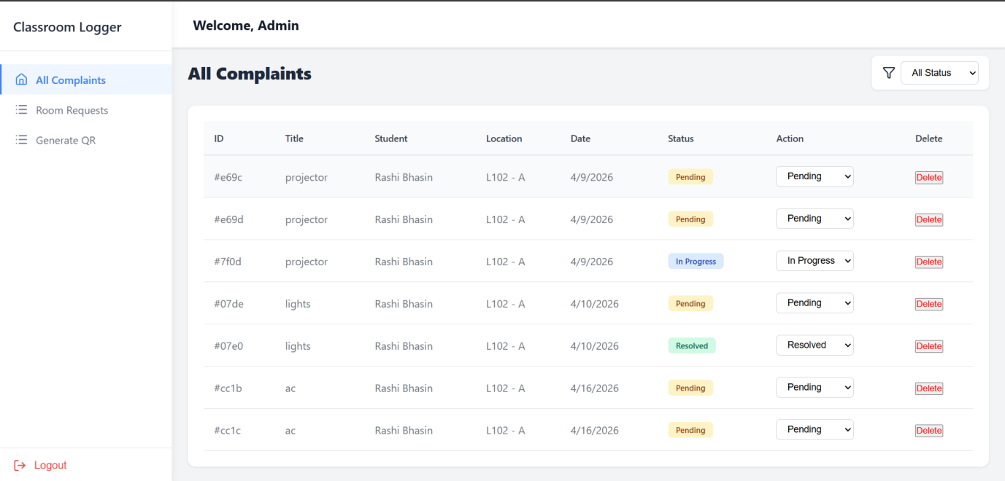
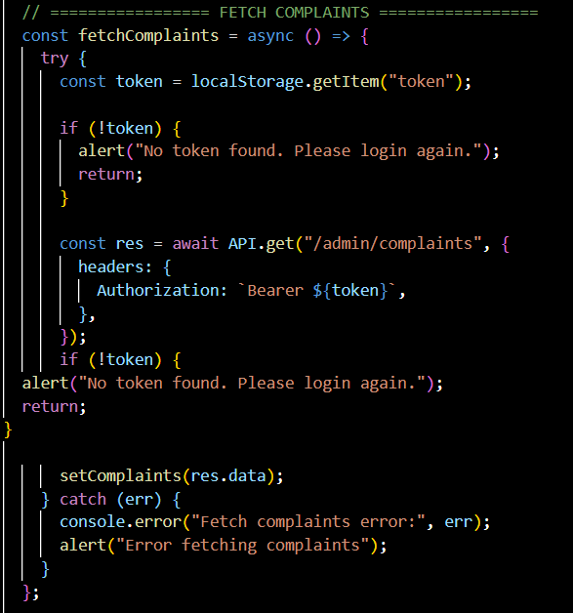
4.1.2 Admin Dashboard : Room Request
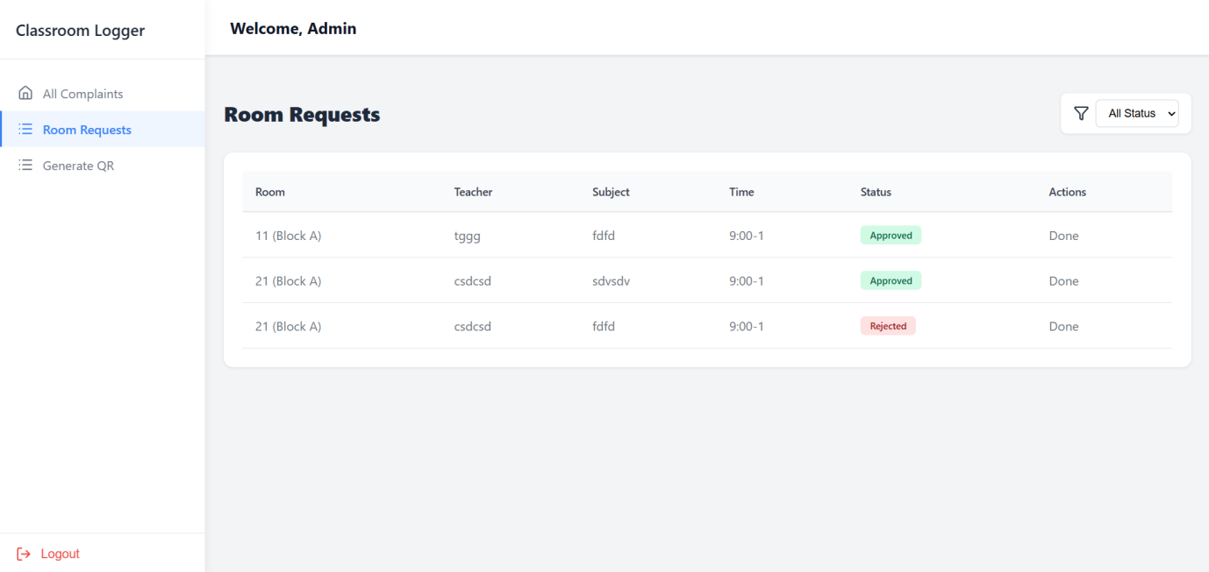
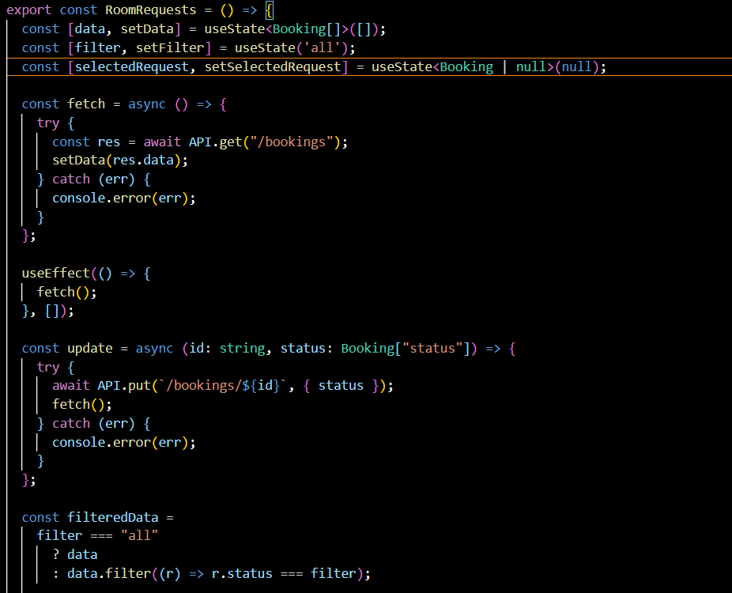

4.1.3 Admin Dashboard : Generate Qr Code
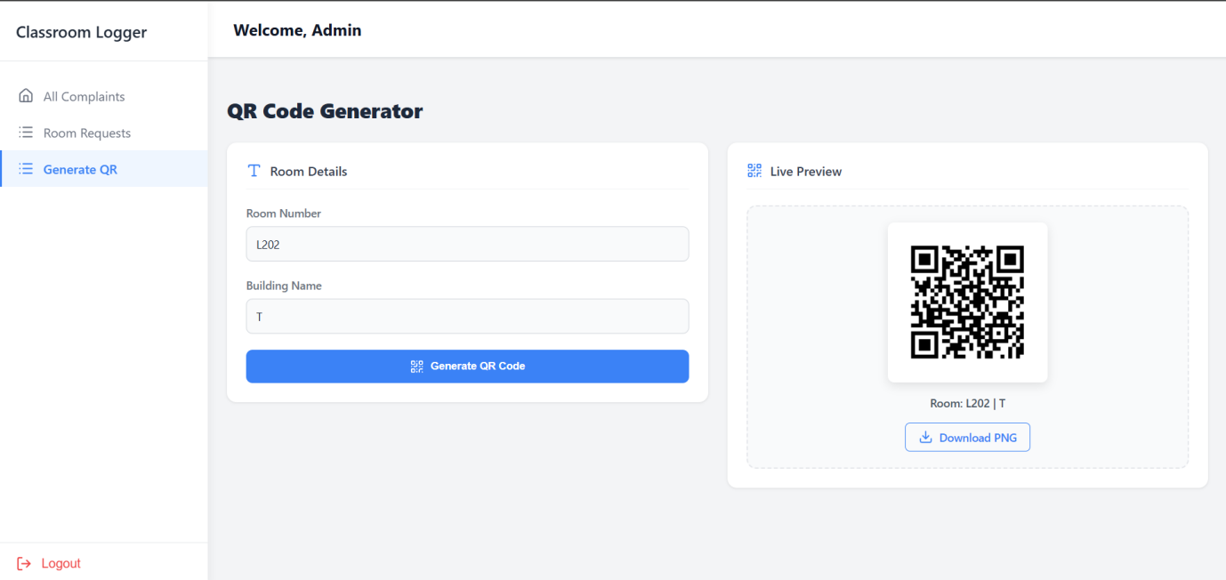
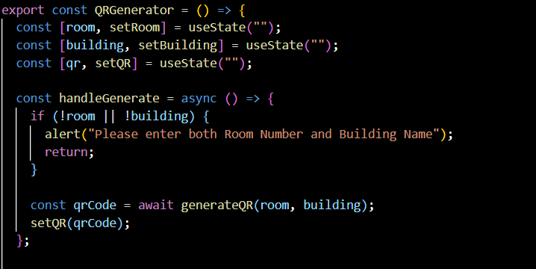

4.1.4 Admin Dashboard : Update Status
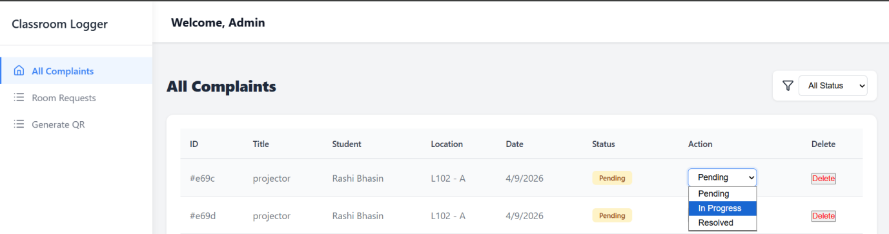
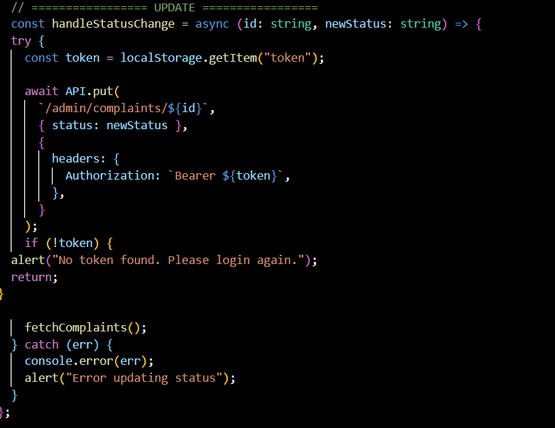

4.1.5 User Dashboard : Raise Complaint
4.1.5.1 Raise Complaint : QR Code
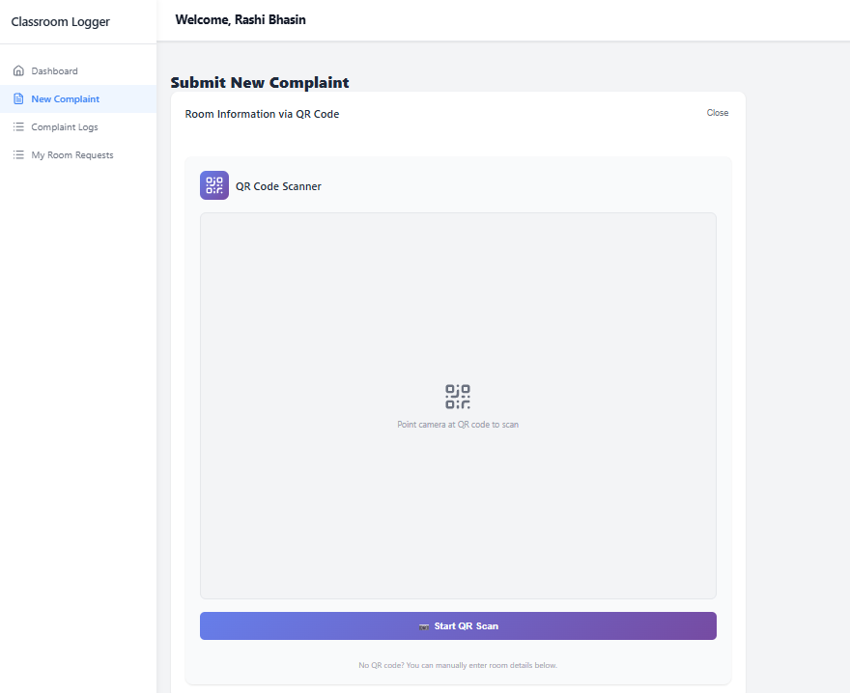
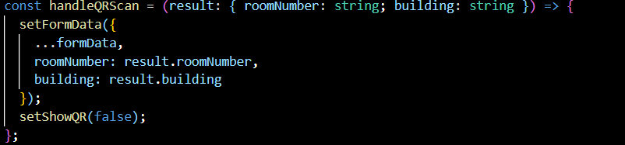

4.1.5.2 Raise Complaint : Manual
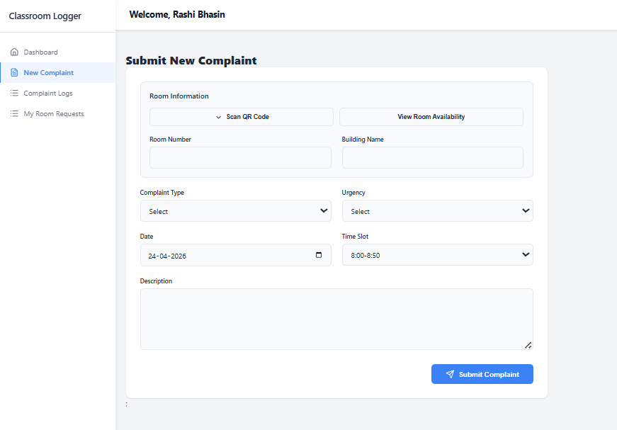
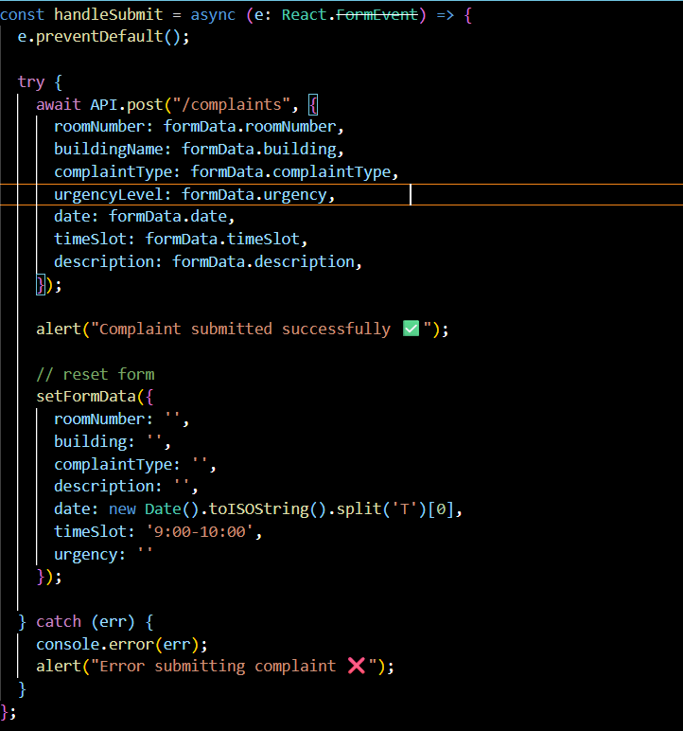
4.1.6 User Dashboard : Complaint Status
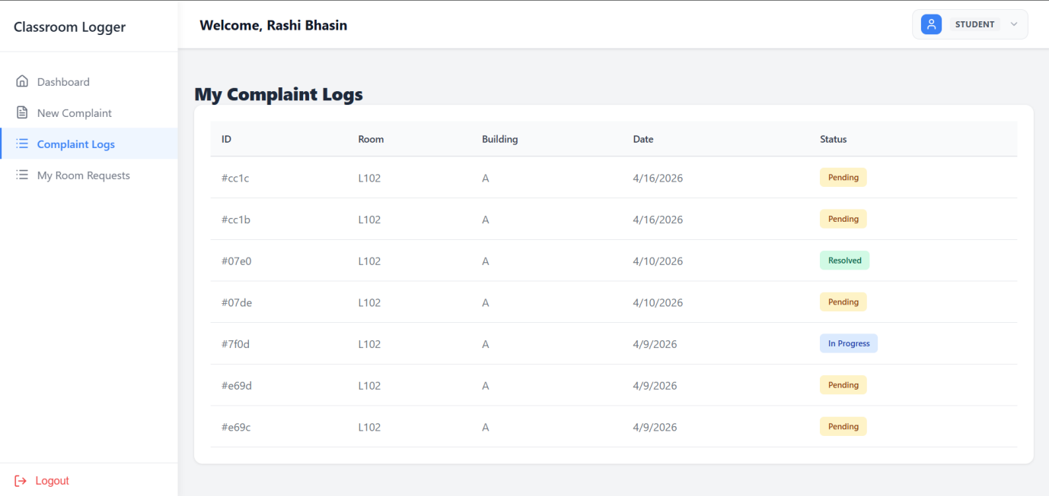
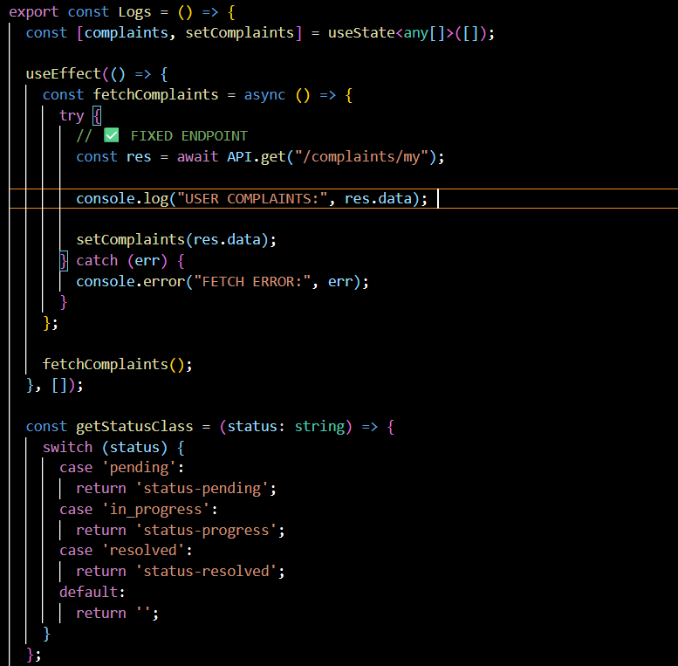
4.1.7 User Dashboard : Room Booking
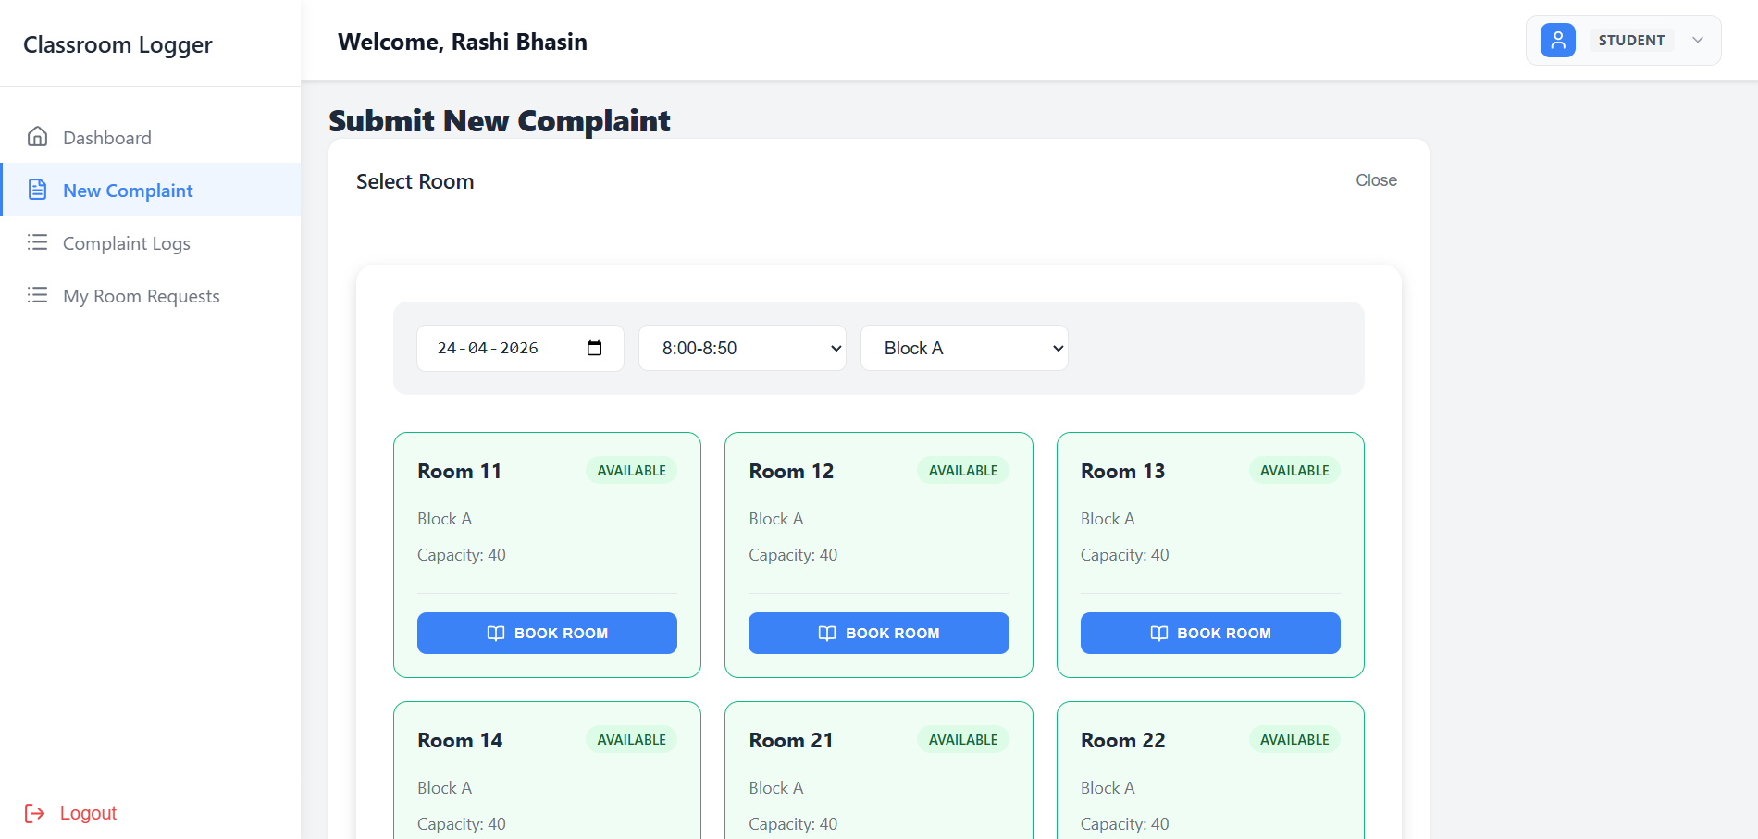
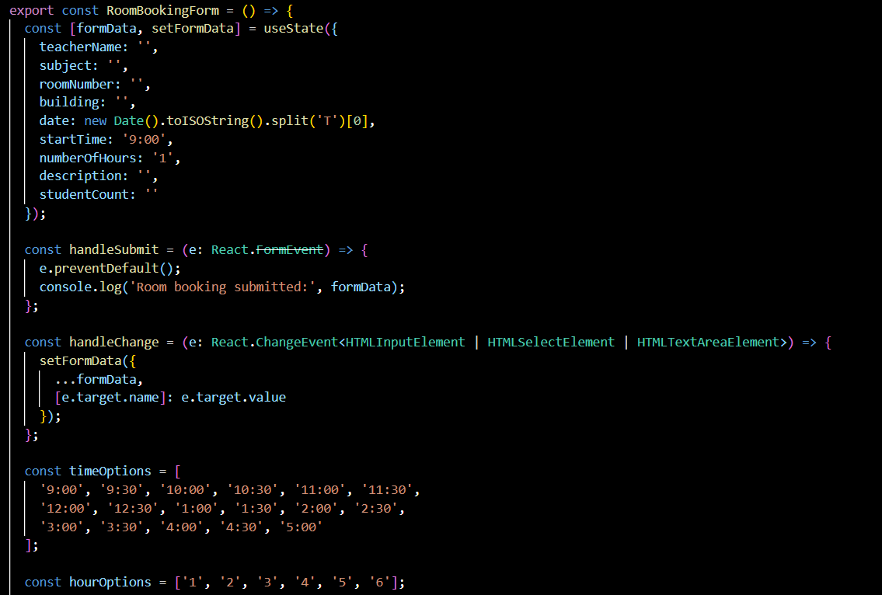

4.1.8 User Dashboard : Room Booked Status
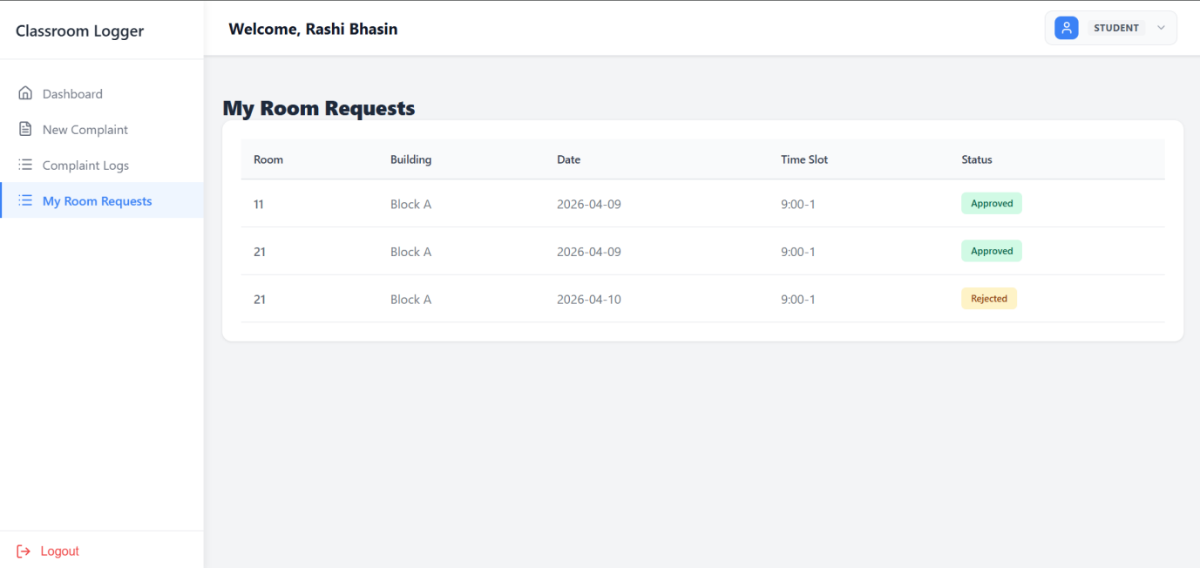
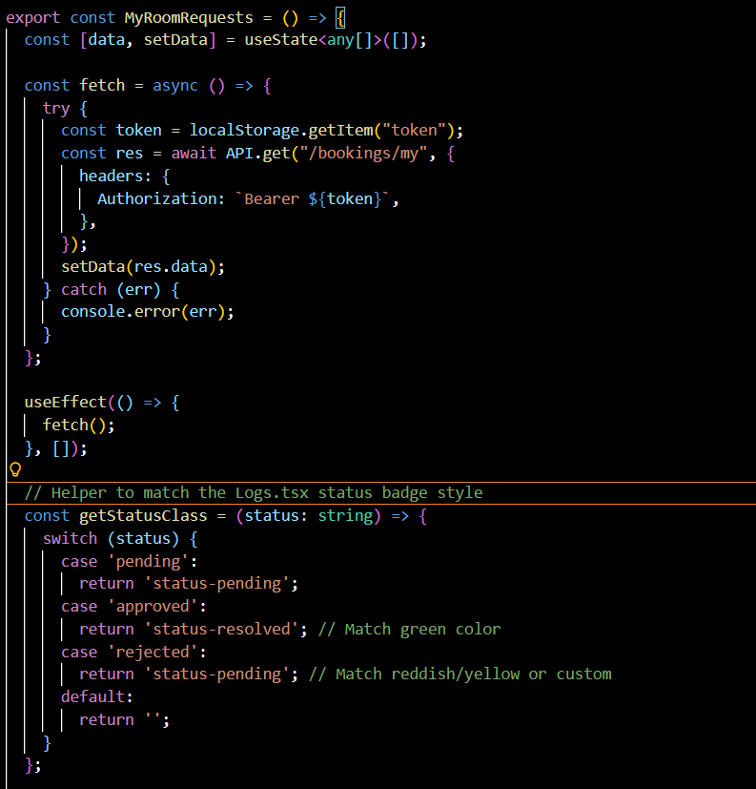

4.2 Cyclomatic complexity calculation for all code snippets
4.1.1 Admin Dashboard : View All Complaints

Step 1: Count Decision Points
Decision statements present:
- if (!token) → first condition
- if (!token) → second condition
- catch(err) → exception handling path (counts as one decision in practical software metrics)
Total decisions = 3

Step 2: Formula
M=D+1
Where:
- M = Cyclomatic Complexity
- D = Number of decision points
So:
M=3+1=4

Final Answer

Cyclomatic Complexity = 4

4.1.2 Admin Dashboard : Room Request

Step 1: Identify Decision Points
The given code contains the following decision points:
- catch(err) in fetch()
- catch(err) in update()
- Ternary condition: filter === "all" ? data : ...
Total decision points = 3

Step 2: Apply Formula
M=D+1M = D + 1M=D+1
Where:
- M = Cyclomatic Complexity
- D = Number of decision points
M=3+1=4

Final Answer
Cyclomatic Complexity = 4

4.1.3 Admin Dashboard : Generate Qr Code

Step 1: Identify Decision Points
The given code contains the following decision point:
- if (!room || !building)
Total decision points = 1

Step 2: Apply Formula
M=D+1M = D + 1M=D+1
Where:
- M = Cyclomatic Complexity
- D = Number of decision points
M=1+1=2

Final Answer
Cyclomatic Complexity = 2

4.1.4 Admin Dashboard : Update Status

Step 1: Identify Decision Points
The given code contains the following decision points:
1.if (!token)
2.catch (err)
Total decision points = 2

Step 2: Apply Formula
[M = D + 1]
Where:
M = Cyclomatic Complexity
D = Number of decision points
[M = 2 + 1 = 3]

Final Answer
Cyclomatic Complexity = 3

4.1.5 User Dashboard : Raise Complaint
4.1.5.1 Raise Complaint : QR Code

Step 1: Identify Decision Points
The given code contains no decision points:
No if, else, loops, or catch
Total decision points = 0

Step 2: Apply Formula
[M = D + 1]
Where:
M = Cyclomatic Complexity
D = Number of decision points
[M = 0 + 1 = 1]

Final Answer
Cyclomatic Complexity = 1

4.1.5.2 Raise Complaint : Manual

Step 1: Identify Decision Points
The given code contains the following decision point:
catch (err)
Total decision points = 1

Step 2: Apply Formula
[M = D + 1]
Where:
M = Cyclomatic Complexity
D = Number of decision points
[M = 1 + 1 = 2]

Final Answer
Cyclomatic Complexity = 2

4.1.6 User Dashboard : Complaint Status

Step 1: Identify Decision Points
The given code contains the following decision points:
1.catch (err) → 1 decision
2.switch (status) with cases:
case 'pending'
case 'in_progress'
case 'resolved'
default
In cyclomatic complexity, each case (except default) is counted.
So:
catch = 1
case statements = 3
Total decision points = 4

Step 2: Apply Formula
[M = D + 1]
Where:
M = Cyclomatic Complexity
D = Number of decision points
[M = 4 + 1 = 5]

Final Answer
Cyclomatic Complexity = 5

4.1.7 User Dashboard : Room Booking

Step 1: Identify Decision Points
The given code contains no decision points:
No if, else, switch, loops, or catch
Total decision points = 0

Step 2: Apply Formula
[M = D + 1]
Where:
M = Cyclomatic Complexity
D = Number of decision points
[M = 0 + 1 = 1]

Final Answer
Cyclomatic Complexity = 1

4.1.8 User Dashboard : Room Booked Status

Step 1: Identify Decision Points
The given code contains the following decision points:
catch (err) → 1 decision
switch (status) with cases:
case 'pending'
case 'approved'
case 'rejected'
In cyclomatic complexity, each case (except default) is counted.
So:
catch = 1
case statements = 3
Total decision points = 4

Step 2: Apply Formula
[M = D + 1]
Where:
M = Cyclomatic Complexity
D = Number of decision points
[M = 4 + 1 = 5]

Final Answer
Cyclomatic Complexity = 5

